**Objective Questions**:

1. What is the total no. of tables present in the data?

**Observation:** In original data, there are 2 tables.

After analysis, there are 15 tables.

1. What is the total no. of attributes present in the data?

**Observation**: Originally there were 27 attributes after analysis there are 68 attributes.

1. How many categorical columns are there in the data?

**Observation:** There are 12 categorial columns in the data the column which has strings called categorial. There are 12 continuous columns.

1. The data consists of some inconsistent and missing values so ensure that the data used for further analysis is cleaned.

**Observation:** There were some missing values in the cuisines column so we had to remove it or put some value there there were 9 missing values and format the date_key opening column into date format.

1. Using the LookUp functions, fill up the countries in the original data using the country code.

**Visualization:**

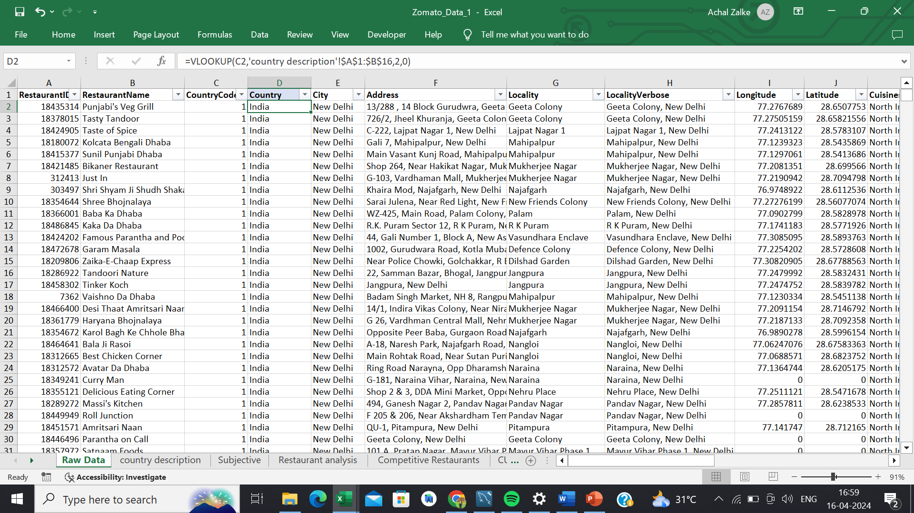

**Observation:** Using the VLookup function, fill up the countries in the original data using the country code.

1. Create a table to represent the number of restaurants opened in each country.

**Visualization:**

|  |  |
| --- | --- |
| **TOTAL NUMBER OF RESTAURANTS** | |
| Country | No of restaurants |
| Australia | 24 |
| Brazil | 60 |
| Canada | 4 |
| India | 8652 |
| Indonesia | 21 |
| New Zealand | 40 |
| Philippines | 22 |
| Qatar | 20 |
| Singapore | 20 |
| South Africa | 60 |
| Sri Lanka | 20 |
| Turkey | 34 |
| United Arab Emirates | 60 |
| United Kingdom | 80 |
| United States of America | 434 |
| **Grand Total** | **9551** |

**Observation:** Created a pivot table to represent the number of restaurants opened in each country. Total there are 9551 restaurants.

1. Also, the management wants to look at the number of restaurants opened each year, so provide them with something here.

**Visualization:**

**Observation:** The above chart shows the number of restaurants opened each year. In 2010 there were 1080 restaurants, in 2011 there were 1098 restaurants, in 2012 there were 1022 restaurants, in 2013 there were 1061 restaurants, in 2014 there were 1051 restaurants, in 2015 there were 1024 restaurants, in 2016 there were 1027 restaurants, in 2017 there are 1086 restaurants, and in 2018 there are 1002 restaurants.

1. What is the total number of restaurants in India in the price range of 4?

**Visualization:**

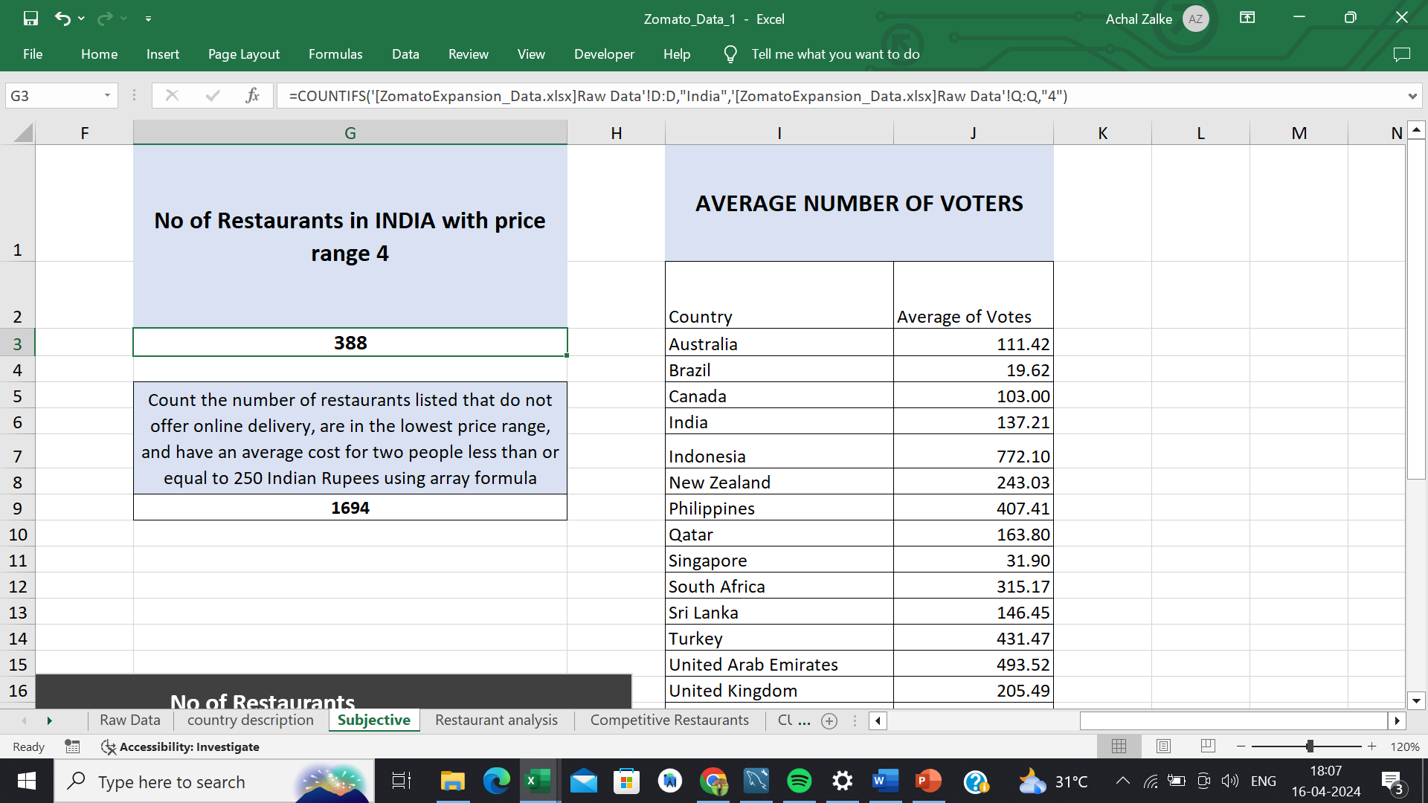

**Observation:** There are 388 restaurants in India in the price range of 4. We have used the countif function to do this.

1. What is the average number of voters for the restaurants in each country according to the data?

**Visualization:**

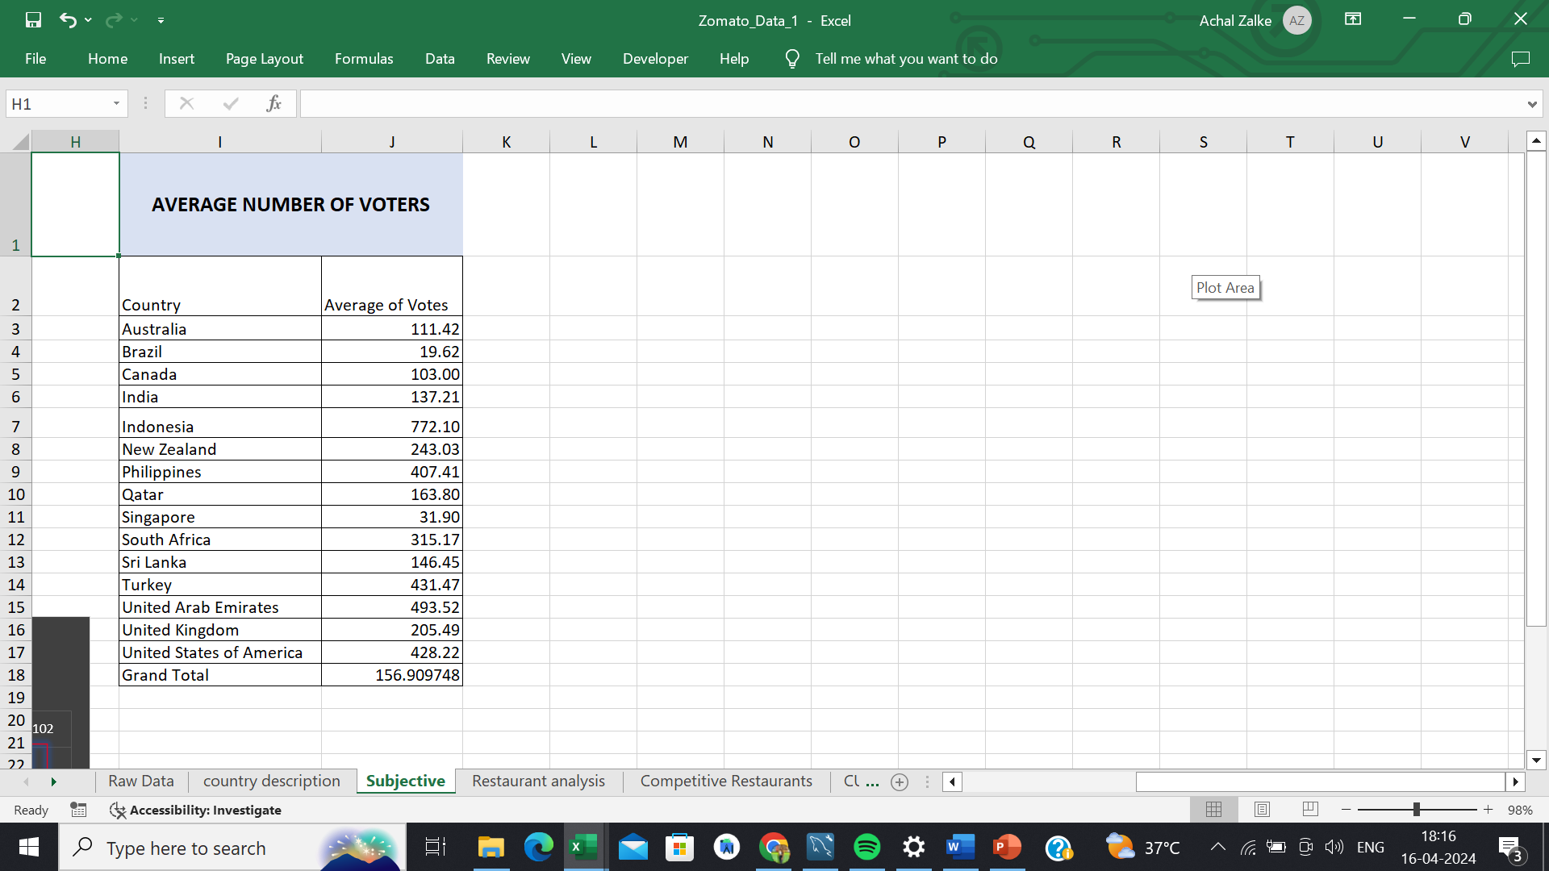

**Observation:** We used a pivot table to answer this question, from the above table we can analyse the average number of voters for the restaurants in each country.

1. Calculate the average rating for all the restaurants that have price_range < 4 and provide online delivery. Use only the “IF” function, Logical Operators, and Aggregation functions to solve this problem.

**Visualization:**

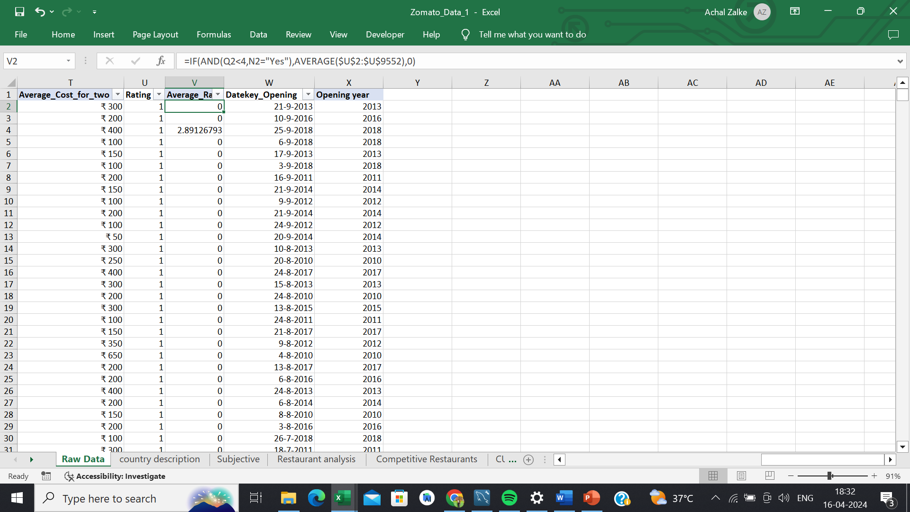

**Observation:** As we can see in the table using the “IF” function, Logical Operators, and Aggregation functions we have calculated the average rating for all the restaurants that have price_range < 4 and provide online delivery.

1. Using Conditional formatting highlight the rows of restaurants that are located in the countries or cities that you’ve suggested to the management for opening new restaurants.

|  |  |
| --- | --- |
| **TOTAL NUMBER OF RESTAURANTS** | |
| Country | No of restaurants |
| Australia | 24 |
| Brazil | 60 |
| Canada | 4 |
| India | 8652 |
| Indonesia | 21 |
| New Zealand | 40 |
| Philippines | 22 |
| Qatar | 20 |
| Singapore | 20 |
| South Africa | 60 |
| Sri Lanka | 20 |
| Turkey | 34 |
| United Arab Emirates | 60 |
| United Kingdom | 80 |
| United States of America | 434 |
| **Grand Total** | **9551** |

**Visualization:**

**Observation:** We have highlighted the rows of restaurants that are located in the countries or cities that you’ve suggested to the management for opening new restaurants using conditional formatting.

1. Create a new customized price column that consists of the abbreviation/symbol of the currency along with the Average_cost_for_two value. [Use string operations to do this task].

**Visualization:**

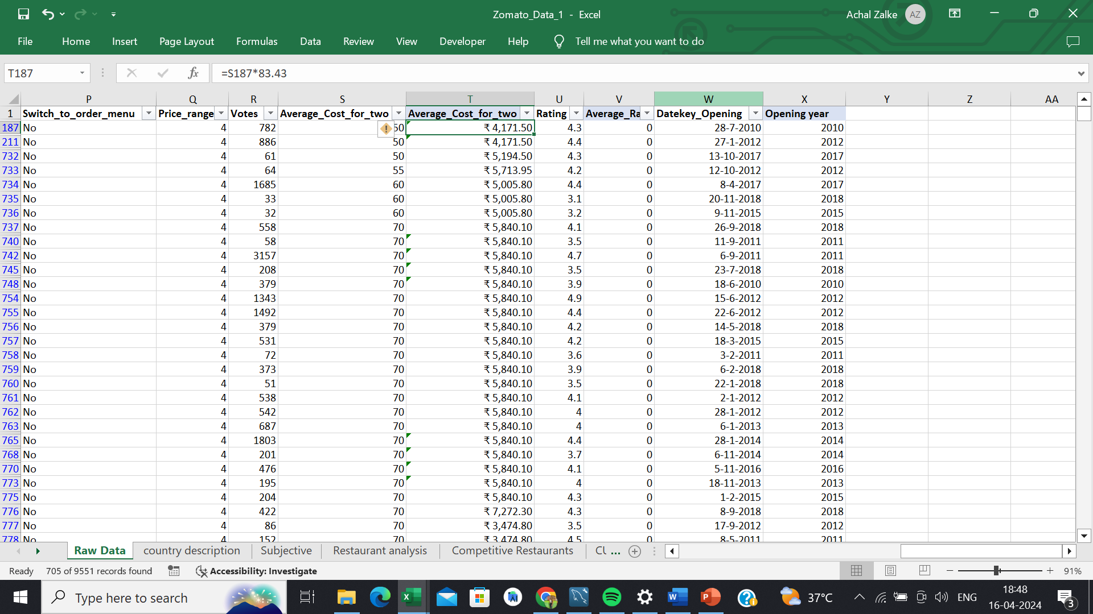

**Observation:** As you can see in the picture, we have created a new customized price column that consists of the abbreviation/symbol of the currency along with the Average_cost_for_two value using string operation.

1. How can you create an array formula in Excel or Google Sheets to count the number of restaurants listed that do not offer online delivery, are in the lowest price range, and have an average cost for two people less than or equal to 250 Indian Rupees?

**Visualization:**

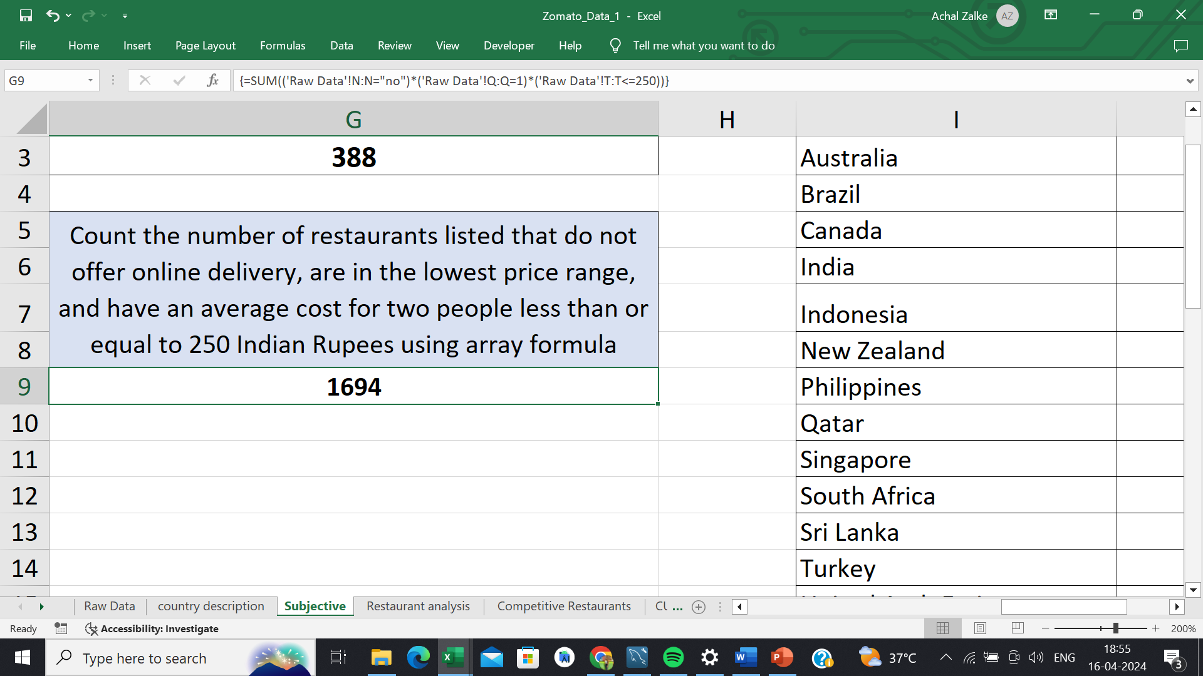

**Observation:** As you can refer to the above picturecreated an array formula in Excel or Google Sheets to count the number of restaurants listed that do not offer online delivery, are in the lowest price range, and have an average cost for two people less than or equal to 250 Indian Rupees.

**Subjective Question:**

1. Suggest a few countries where the team can open newer restaurants with lesser competition. Which visualization/technique will you use here to justify the suggestions?

**Visualization:**

**Insights:**

* Suggested countries: Indicates the countries which have less number of restaurants.

**Recommendations:**

* Business Strategy: We should open new restaurants in these countries because competition will be less so we can grow our business.

1. Come up with the names of States and cities in the suggested countries suitable for opening restaurants.

**Visualization:**

|  |  |  |
| --- | --- | --- |
| **CITIES SUITABLE FOR OPENING RESTAURANTS** | | |
| **Cities in suggested countries** | **No of Restaurant** | **Average of Rating** |
| **Canada** | **4** | **3.6** |
| Chatham-Kent | 1 | 3.7 |
| Consort | 1 | 3.0 |
| Vineland Station | 1 | 4.3 |
| Yorkton | 1 | 3.3 |
| **Indonesia** | **21** | **4.3** |
| Bandung | 1 | 4.2 |
| Bogor | 2 | 3.9 |
| Jakarta | 16 | 4.4 |
| Tangerang | 2 | 4.3 |
| **Philippines** | **22** | **4.5** |
| Makati City | 2 | 4.7 |
| Mandaluyong City | 4 | 4.6 |
| Pasay City | 3 | 4.4 |
| Pasig City | 3 | 4.6 |
| Quezon City | 1 | 4.8 |
| San Juan City | 2 | 4.3 |
| Santa Rosa | 2 | 3.8 |
| Tagaytay City | 1 | 4.5 |
| Taguig City | 4 | 4.5 |
| **Qatar** | **20** | **4.1** |
| Doha | 20 | 4.1 |
| **Singapore** | **20** | **3.6** |
| Singapore | 20 | 3.6 |
| **Sri Lanka** | **20** | **3.9** |
| Colombo | 20 | 3.9 |
| **Grand Total** | **107** | **4.0** |

**Insights:**

* Suggested cities: Indicates which cities are suitable for opening restaurants.
* Number of restaurants: Indicates the number of restaurants should be open in suggested countries and cities.
* Average rating: Indicates the average of the restaurants.

**Recommendation:**

* Business strategy: In cities where a number of restaurants and ratings is also less we can open new restaurants because there will be less competition so we can grow our business.

1. According to the countries you suggested, what is the current quality regarding ratings for restaurants that are open there?

**Visualization:**

|  |  |
| --- | --- |
| **CURRENT QUALITY** | |
| **Countries** | **Average of Rating** |
| Canada | 3.6 |
| Indonesia | 4.3 |
| Philippines | 4.5 |
| Qatar | 4.1 |
| Singapore | 3.6 |
| Sri Lanka | 3.9 |
| **Grand Total** | **4.0** |

**Insights:**

* Current quality: Indicate the current quality of food through rating for restaurants that are open there.

**Recommendation:**

* The current quality of the food in the restaurants opened in the suggested is not that good, it is moderate so we can open a restaurants which have good quality food which will help us to increase are rating.

1. Also, what is the current expenditure on food in the suggested countries, so we can keep our financial expenditure in control?

**Visualization:**

**Insights:**

* Current expenditure: Indicate the current expenditure of the restaurants in suggested countries.

**Recommendation:**

* After demonstrating the above chart we should keep our expenditure less to keep our financial expenditure in control.

1. Come up with the names of restaurants from the recommended states that are our biggest competitors and also those that are rated in the lower brackets, i.e. 1-2 or 2-3.

**Visualization:**

|  |  |  |  |  |  |  |  |
| --- | --- | --- | --- | --- | --- | --- | --- |
| **LESS RATED RESTAURANTS** | | | | | | | |
|  |
| **Average of Rating** | **Column Labels** |  |  |  |  |  |  |  |
| **Row Labels** | **Canada** | **Indonesia** | **Philippines** | **Qatar** | **Singapore** | **Sri Lanka** | **Grand Total** |  |
| Consort Restaurant | 3 |  |  |  |  |  | 3 |  |
| Elite Indian Restaurant |  |  |  |  |  | 2.4 | 2.4 |  |
| Makansutra Gluttons Bay |  |  |  |  | 3 |  | 3 |  |
| Queen's Cafe |  |  |  |  |  | 2.5 | 2.5 |  |
| **Grand Total** | **3** |  |  |  | **3** | **2.45** | **2.725** |  |

**Insight:**

* Biggest competitors: Indicates the restaurants from the recommended states that are our biggest competitors.
* Lower brackets: Indicates the less-rated restaurants from the recommended cities.

**Recommendation:**

* We should open are restaurants in the cities where the rating is low and we should ignore opening restaurants in the cities and locality where we have our competitors.

1. Which cuisines should we focus on in the newer restaurants to get better feedback? Does the choice of cuisines affect the restaurant ratings?

**Visualization:**

**Insights:**

* Cuisines analysis: Indicates top-rated cuisines in the suggested countries.
* Average rating: Indicates the rating of the cuisines in the suggested countries.

**Recommendation:**

* We should focus on the cuisine while opening new restaurants which are listed above because each cuisine rated above 4 hence it will help us to increase our rating.

1. According to our current data, should we go for online delivery and table booking? Does that affect the customer’s ratings?

**Visualization:**

**Insights:**

* Online delivery and table booking preferences: Indicates whether online delivery and table booking is available or not.
* Average rating: Indicates the average rating of table booking and online delivery is available or not.

**Recommendation:**

* According to our current data, we should go for online delivery and table booking.
* It will affect our rating because where there is online delivery and table booking rating is high as compared to where there is no online delivery and table booking.
* It will help us to increase our rating.

1. Should the team keep the rate of cuisines higher? Will that affect the feedback? According to our data are the rates of cuisines and ratings, correlated?

**Visualization:**

|  |  |
| --- | --- |
| CORRELATION | |
| CORRELATION | 0.808049 |

**Insights:**

* Correlation: Indicates the rate of the cuisines and ratings are correlated.

**Recommendation:**

* As we can see the rates of cuisines and the ratings arehighly correlated so if the rate of cuisines increases the rating will also increase.
* So according to the analysis we should keep the rates of cuisines higher.

1. What is the distribution of the number of restaurants of different price ranges in all the countries?

**Visualization:**

|  |  |  |  |  |  |
| --- | --- | --- | --- | --- | --- |
| **DISTRIBUTION OF RESTAURANTS OF DIFFERENT PRICE RANGE** | | | | | |
|  |
| **Count of Restaurants** | **Column Labels** |  |  |  |  |  |
| **Countries** | **1** | **2** | **3** | **4** | **Grand Total** |  |
| Australia | 4 | 14 | 5 | 1 | 24 |  |
| Brazil | 2 | 7 | 16 | 35 | 60 |  |
| Canada |  | 3 |  | 1 | 4 |  |
| India | 4295 | 2858 | 1111 | 388 | 8652 |  |
| Indonesia |  | 1 | 20 |  | 21 |  |
| New Zealand | 3 | 4 | 17 | 16 | 40 |  |
| Philippines |  | 1 | 12 | 9 | 22 |  |
| Qatar |  | 1 | 5 | 14 | 20 |  |
| Singapore |  | 1 | 5 | 14 | 20 |  |
| South Africa |  | 4 | 17 | 39 | 60 |  |
| Sri Lanka |  | 6 | 11 | 3 | 20 |  |
| Turkey |  | 11 | 18 | 5 | 34 |  |
| United Arab Emirates |  | 9 | 29 | 22 | 60 |  |
| United Kingdom | 4 | 28 | 32 | 16 | 80 |  |
| United States of America | 136 | 165 | 110 | 23 | 434 |  |
| **Grand Total** | **4444** | **3113** | **1408** | **586** | **9551** |  |

**Insights:**

* Distribution of restaurants: Indicates the distribution of restaurants according to the different price ranges.
* Price range: Indicates different price ranges across different countries.

**Recommendation**:

* So as we can see from the above table where the price range is low the number of restaurants are more and where price range is high the number of restaurants are less.
* We should keep the price range of our restaurants medium or high which will help us to grow our restaurants.

1. Explain your approach in brief for suggesting countries/cities in order to open new restaurants, if the objective and subjective questions would have not been given to assist you.

* We should open our restaurants in countries that have less number of restaurants.
* We should open restaurants where the number of restaurants is less and the rating is also less.
* We should keep our expenditure less to keep our to keep track of our financial expenditure.
* Restaurants must include top-rated cuisines.
* Restaurants must-have table booking and online delivery which help increase the rating.
* We should keep the price range of our restaurants medium or high which will help us to grow our restaurants.
* As we can see the rates of cuisines and the ratings arehighly correlated so if the rate of cuisines increases the rating will also increase.
* So according to the analysis we should keep the rates of cuisines higher.